**Operation Manual**

Technical Support for ICT Learning Centers (ILC) Network Operations

**Instruction/Operation for ILC Administrator:**

**Step-1**: Find file named **Install.bat** from the given filesand click on it. This will create two scheduled tasks at task scheduler named respectively users and ftp.

**Step-2:** Configuring task schedule. The steps are given as below:

1. Press the **windows** button and type Windows Firewall. Then the following screen will be shown:

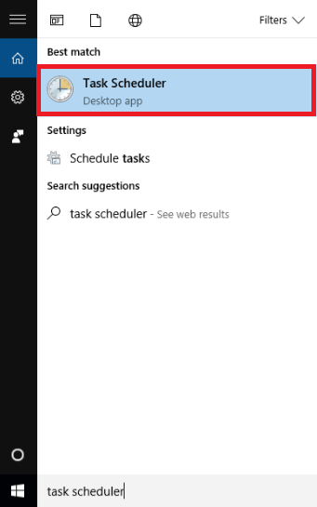

Now by clicking on the task scheduler then click on Task Scheduler Library you will find something like this.

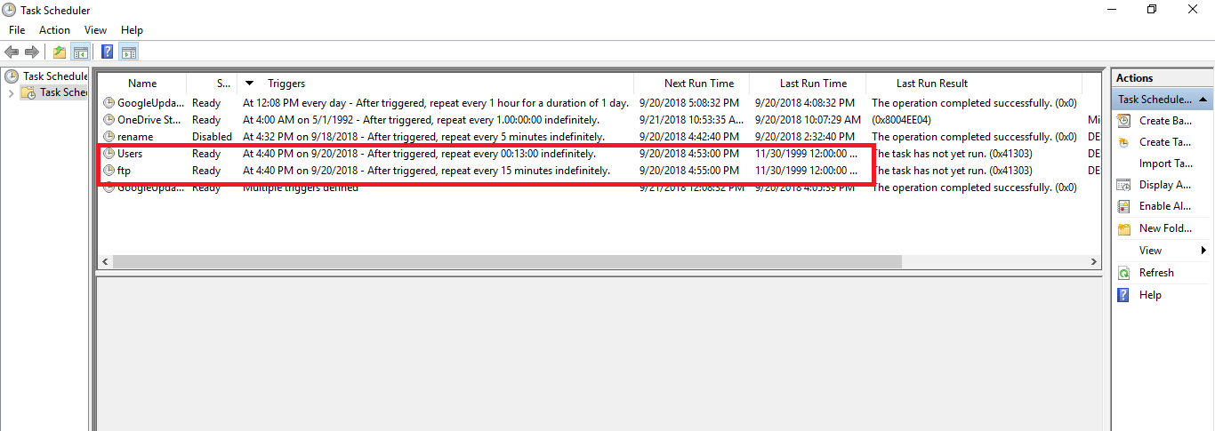

**Step-3:**

Double click on ftp and this window will pop up then you check these options just like below

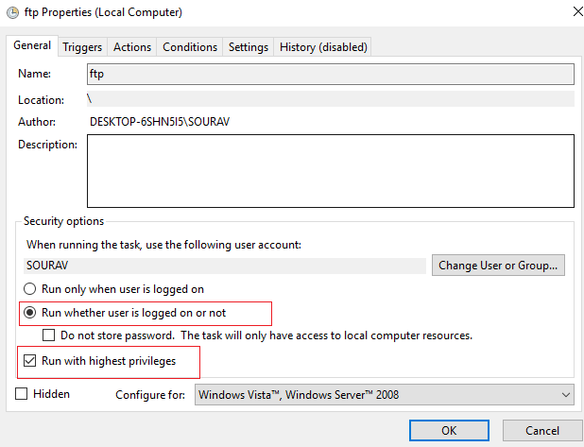

**Step-4:**

Then you have to select action part of that window and something like this will appear.

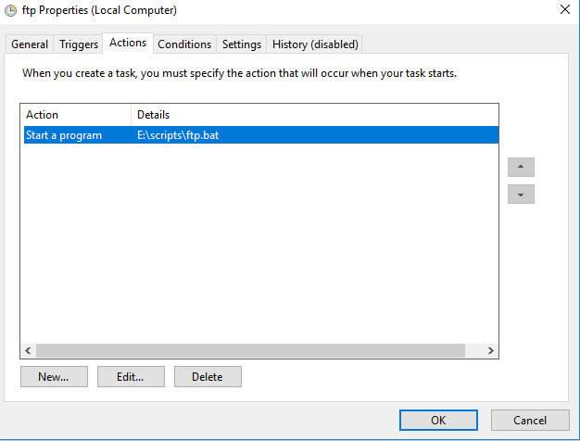

**Step-5:**

Double click on the “Start a program” and this will appear

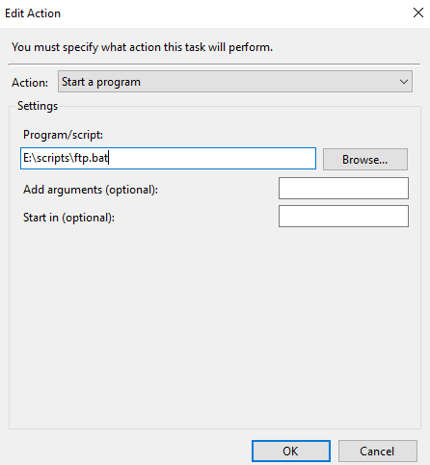

**Step-6:**

Now you have to put a quotation sign (“”) aroundE:\scripts\ftp.bat e.g. “E:\scripts\ftp.bat”

& write E:\scripts in the field Start in (optional) just like this

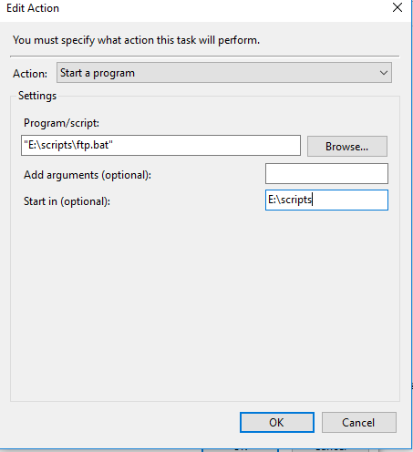

Now click ok to everywhere you meet.

Step-7: Now you are done and many congratulations to you for getting it done!